

**ID VALIDATION SYSTEM**

**SYSTEM OPERATION DOCUMENT**

MAB/GROUP IT/SOD/ID VALIDATION SYSTEM/1.1

##### Prepared by:

##### IDVS Support Team

##### Application Management Services (AMS)

##### Group IT

**ALL INFORMATION CONTAINED HEREIN IS RESTRICTED AND SHALL BE KEPT FOR INTERNAL USE ONLY**. None of this information shall be divulged to persons other than Malaysia Airlines Berhad employees and contractors authorized by the nature of their duties to receive such information, or individuals or organisations authorised by Malaysia Airlines Berhad in accordance with existing policy regarding release of company information.

**INTENTIONALLY LEFT BLANK**

|  |  |  |  |
| --- | --- | --- | --- |
| Prepared By | : |  |  |
|  |  | RajashekarReddy Kasireddy |  |
|  |  | IDVS Support Team |  |
|  |  | Application Management Services |  |
|  |  |  |  |
| Reviewed By | :  : | |  | | --- | |  | | |  | | --- | | Suman Guduru | | OST SRAS Tower Manager | | Application Management Services | | |  |
|  |  | Mohd Nazri Abu Seman |  |
|  |  | System Owner  Head, Cyber Security & End User Technology  Information Technology |  |
| Approved By | : |  |  |
|  |  | Siti Hafsah Mohd Desa |  |
|  |  | Head, Airline Operations  Information Technology |  |
|  |  | Group IT |  |

**INTENTIONALLY LEFT BLANK**

**TABLE OF CONTENTS**

**Contents Page**

[PART 1 - MANUAL ADMINISTRATION 1-1](#_Toc519790026)

[1.1. RECORD OF REVISION 1-2](#_Toc519790027)

[1.2. LIST OF EFFECTIVE PAGES 1-3](#_Toc519790028)

[1.3. DISTRIBUTION LIST 1-](#_Toc519790029)5

[1.4. LIST OF ABBREVIATIONS 1-](#_Toc519790030)5

[1.5. CONDITION OF USE 1-](#_Toc519790031)6

[1.6. CONTROL OF MANUAL 1-](#_Toc519790032)6

[PART 2 - MANUAL BACKGROUND 2-1](#_Toc519790033)

[2.1 INTRODUCTION 2-2](#_Toc519790034)

[2.2 PURPOSE 2-2](#_Toc519790035)

[2.3 SCOPE AND APPLICATION 2-2](#_Toc519790036)

[2.4 TERMINOLOGY 2-2](#_Toc519790037)

[2.5 REFERENCES 2-](#_Toc519790038)3

[PART 3 – OVERVIEW OF BUSINESS PROCESS 3-1](#_Toc519790039)

[3.1 OVERVIEW OF BUSINESS PROCESS 3-2](#_Toc519790040)

[PART 4 – MANUAL CONTENT 4-1](#_Toc519790041)

[4.1 Systems overview 4-2](#_Toc519790042)

[4.2 SYSTEM CONCEPT DIAGRAM 4-3](#_Toc519790043)

[4.3 INTERFACES 4-3](#_Toc519790044)

[4.3.1 User Interfaces 4-3](#_Toc519790045)

[4.3.2 System Interfaces 4-](#_Toc519790046)4

[4.4 WARRANTY AND MAINTENANCE PERIOD 4-4](#_Toc519790047)

[4.5 ROLES AND RESPONSIBILITIES 4-](#_Toc519790048)5

[4.6 Technical specifications 4-](#_Toc519790049)8

[4.6.1 Hardware specifications 4-](#_Toc519790050)8

[4.6.2 Software specifications 4-](#_Toc519790051)10

[4.6.3 Communication / Network Specification 4-](#_Toc519790052)10

[4.6.4 User and Equipment Locations 4-](#_Toc519790053)12

[4.6.5 File Management 4-1](#_Toc519790054)2

[4.6.5.1 Libraries and files 4-1](#_Toc519790055)2

[4.6.5.2 DBMS setup 4-1](#_Toc519790056)2

[4.7 Technical operations guide 4-1](#_Toc519790057)2

[4.7.1 Installation Procedures 4-1](#_Toc519790058)3

[4.7.2 Backup and Recovery 4-1](#_Toc519790059)3

[4.7.3 System Startup and Restart 4-1](#_Toc519790060)4

[4.7.4 System Shutdown 4-1](#_Toc519790061)4

[4.7.5 Monitoring Tools 4-1](#_Toc519790062)4

[4.7.6 Source Code Version Control 4-1](#_Toc519790063)4

[4.7.7 Preparation of Production Environment 4-1](#_Toc519790064)4

[4.7.7.1 Program / macro 4-1](#_Toc519790065)4

[4.7.7.2 Network Definitions 4-1](#_Toc519790066)4

[4.7.7.3 Desktop Configuration 4-1](#_Toc519790067)5

[4.7.8 Batch Jobs 4-1](#_Toc519790068)5

[4.7.9 Report Management 4-1](#_Toc519790069)5

[4.8 Maintenance and support 4-1](#_Toc519790070)6

[4.8.1 Problem Logging 4-1](#_Toc519790071)6

[4.8.2 Problem Categorization and Escalation 4-1](#_Toc519790072)7

[4.8.3 Application / Technical Support 4-1](#_Toc519790073)7

[4.9 User guide 4-1](#_Toc519790074)9

[4.9.1 Accessing the Application 4-1](#_Toc519790075)9

[4.10 Contract management 4-1](#_Toc519790076)9

[4.11 Handover items 4-](#_Toc519790077)20

[4.12 Information security 4-](#_Toc519790078)20

[4.13 Documentation and references 4-2](#_Toc519790079)2

[AppendiX i](#_Toc519790080)

1. - MANUAL ADMINISTRATION

# RECORD OF REVISION

| **No.** | **Description Of Changes** | **Issue No.** | **Rev. No.** | **Author** | **Effective Date** |
| --- | --- | --- | --- | --- | --- |
| 1 | Original – Initial document | 1 | 0 | Rajeswari Killa | 16-Jul-18 |
| 2 | Update AMS SDM and Application support details | 1 | 1 | RajashekarReddy Kasireddy | 27-Sep-19 |
| 3 | Updated contract management details | 1 | 1 | Rajashekarreddy Kasireddy | 25-Jun-20 |
| 4 | Updated change request | 1 | 2 | Rajashekarreddy Kasireddy | 12-August-2020 |
|  |  |  |  |  |  |
|  |  |  |  |  |  |
|  |  |  |  |  |  |
|  |  |  |  |  |  |
|  |  |  |  |  |  |
|  |  |  |  |  |  |

# LIST OF EFFECTIVE PAGES

|  |  |  |  |  |  |  |  |  |  |  |
| --- | --- | --- | --- | --- | --- | --- | --- | --- | --- | --- |
| **Part** | **Page** | **Issue No.** | **Revision No.** | **Effective Date** |  | **Part** | **Page** | **Issue No.** | **Revision No.** | **Effective Date** |
| 1 | 1-1 | 1 | 0 | 16-07-18 |  |  | 4-19 | 1 | 0 | 16-07-18 |
|  | 1-2 | 1 | 0 | 16-07-18 |  |  | 4-20 | 1 | 0 | 16-07-18 |
|  | 1-2 | 1 | 1 | 27-09-19 |  |  | 4-20 | 1 | 1 | 27-09-19 |
|  | 1-3 | 1 | 0 | 16-07-18 |  |  |  |  |  |  |
|  | 1-4 | 1 | 1 | 30-07-20 |  |  |  |  |  |  |
|  | 1-5 | 1 | 0 | 16-07-18 |  |  |  |  |  |  |
|  | 1-6 | 1 | 0 | 16-07-18 |  |  |  |  |  |  |
| 2 | 2-1 | 1 | 0 | 16-07-18 |  |  |  |  |  |  |
|  | 2-2 | 1 | 0 | 16-07-18 |  |  |  |  |  |  |
| 3 | 3-1 | 1 | 0 | 16-07-18 |  |  |  |  |  |  |
|  | 3-2 | 1 | 0 | 16-07-18 |  |  |  |  |  |  |
| 4 | 4-1 | 1 | 0 | 16-07-18 |  |  |  |  |  |  |
|  | 4-2 | 1 | 0 | 16-07-18 |  |  |  |  |  |  |
|  | 4-3 | 1 | 0 | 16-07-18 |  |  |  |  |  |  |
|  | 4-4 | 1 | 0 | 16-07-18 |  |  |  |  |  |  |
|  | 4-5 | 1 | 0 | 16-07-18 |  |  |  |  |  |  |
|  | 4-6 | 1 | 0 | 16-07-18 |  |  |  |  |  |  |
|  | 4-7 | 1 | 0 | 16-07-18 |  |  |  |  |  |  |
|  | 4-8 | 1 | 0 | 16-07-18 |  |  |  |  |  |  |
|  | 4-9 | 1 | 0 | 16-07-18 |  |  |  |  |  |  |
|  | 4-10 | 1 | 1 | 25-06-20 |  |  |  |  |  |  |
|  | 4-11 | 1 | 0 | 16-07-18 |  |  |  |  |  |  |
|  | 4-12 | 1 | 0 | 16-07-18 |  |  |  |  |  |  |
|  | 4-13 | 1 | 0 | 16-07-18 |  |  |  |  |  |  |
|  | 4-14 | 1 | 0 | 16-07-18 |  |  |  |  |  |  |
|  | 4-15 | 1 | 1 | 27-09-19 |  |  |  |  |  |  |
|  | 4-16 | 1 | 0 | 16-07-18 |  |  |  |  |  |  |
|  | 4-17 | 1 | 0 | 16-07-18 |  |  |  |  |  |  |
|  | 4-18 | 1 | 0 | 16-07-18 |  |  |  |  |  |  |

# 1.3 DISTRIBUTION LIST

|  |  |  |
| --- | --- | --- |
| **NAME** | **DEPT / AREA** | **DESIGNATION** |
| Siti Hafsah Mohd Desa | Group IT | Head, Airlines Operations Information Technology |
| Wan Mohd Husni Wan Hussein | AMS | AMS SDM |
| Mohd Nazri Abu Seman | Head. IT – Risk and Governance | Head, Cyber Security & End User Technology  Information Technology |
|  |  |  |

Table 1 - Distribution List

**1.4 LIST OF ABBREVIATIONS**

The following are the abbreviations used for the purpose of simplification.

|  |  |
| --- | --- |
| **Abbreviation** | **Denote** |
| BU | Business Users |
| BCD | Business Critical Definition |
| DBA | Database Administrator |
| Group IT | Group Information Technology division |
| IDVS | ID Validation System |

Table 2 – List of Abbreviations

**1.5 CONDITION OF USE**

* + 1. This manual is the property of Malaysia Airlines Berhad.
    2. All copies assigned to individual position(s), section(s) or station(s) is on loan basis. If, for any reason, the position(s), section(s) or station(s) is abolished from the company organization, the respective copy(ies) of the manual must be returned to Head, Airlines Operations Information Technology.
    3. In the event where the title of the position or section is changed, the department concerned shall inform Head, Airlines Operations Information Technology promptly.
    4. The content of this manual shall not be copied, or communicated in part or as a whole, to any person not employed by the Company without the express written consent of the Head, Airlines Operations Information Technology.
    5. It is the responsibility of the holder to ensure that his copy is updated to the latest amendments and is in good state of condition.

**1.6 CONTROL OF MANUAL**

* + 1. The contents of this manual shall not be deleted, added, or altered in any way without the approval of the Head, Airlines Operations Information Technology.
    2. Any page which carries an amendment must bear the new revision date. Any line which is amended shall be highlighted by a revision bar (i.e. dark vertical line) drawn close to the amended text on the outside border of the document.
    3. A transmittal letter must accompany the amended pages to advise the holders how to effect the amendment to their copies.
    4. Holders shall notify this department in writing for loss of manual and to obtain a replacement copy. Head, Airlines Operations Information Technology shall ensure that this manual reviewed at least once a year and effect necessary amendments as and when necessary. Should any person(s) envisage improvements needed for the contents of this manual, the person should direct the request to the Head, Airlines Operations Information Technology

**INTENTIONALLY LEFT BLANK**

1. - MANUAL BACKGROUND

# INTRODUCTION

This is the IDVS SOD, hereinafter referred to as “the Policy” provides comprehensive operating procedures within the scope and application herein defined in Part 2 Section 3.0 for Malaysia Airlines Berhad (MAB).

# PURPOSE

The objective of this document is to provide a coherent description of the overall design of the IDVS to enable and assist the technical and development team in the development and implementation of the System.

IT Operations management to prepare for applicable support. The maintenance team to support, maintain and/or enhance the system once in the production environment. It is intended that this document will form the basis of IDVS detailed design.

# SCOPE AND APPLICATION

This document covers relevant information required to operate and support the IDVS in production environment. This covers the maintenance operation of the system, database and interfaces. The application support team shall provide maintenance support for the application level.

# TERMINOLOGY

| **No** | **Term** | **Description** |
| --- | --- | --- |
| 1 | UAT | User Acceptance Test |
| 2 | DR | Disaster Recovery |
| 3 | DB | Database |
| 5 | SOD | System Operational Document |
| 6 | SOW | Statement of Work |

Table 3 – Terminology

* 1. **REFERENCES**

| **No** | **Document** | **Description** |
| --- | --- | --- |
| 1 | User Guide | User Guide |
| 2 | SOW | Statement of Work as supplied as agreed upon between ATOS and MAB |
| 3 | Technical Design Document | Document highlighting the Technical Design & architecture of the collaboration platform. This is supplied by ATOS |
| 4 | Test Plan Document | Document highlighting the Test plan for the collaboration platform. This is supplied by ATOS |
| 5 | Functional Document | Document highlighting all the functional requirements of the system. This is supplied by ATOS |

Table 4 - References

PART 3 – OVERVIEW OF BUSINESS PROCESS

# 

# 3.1 OVERVIEW OF BUSINESS PROCESS

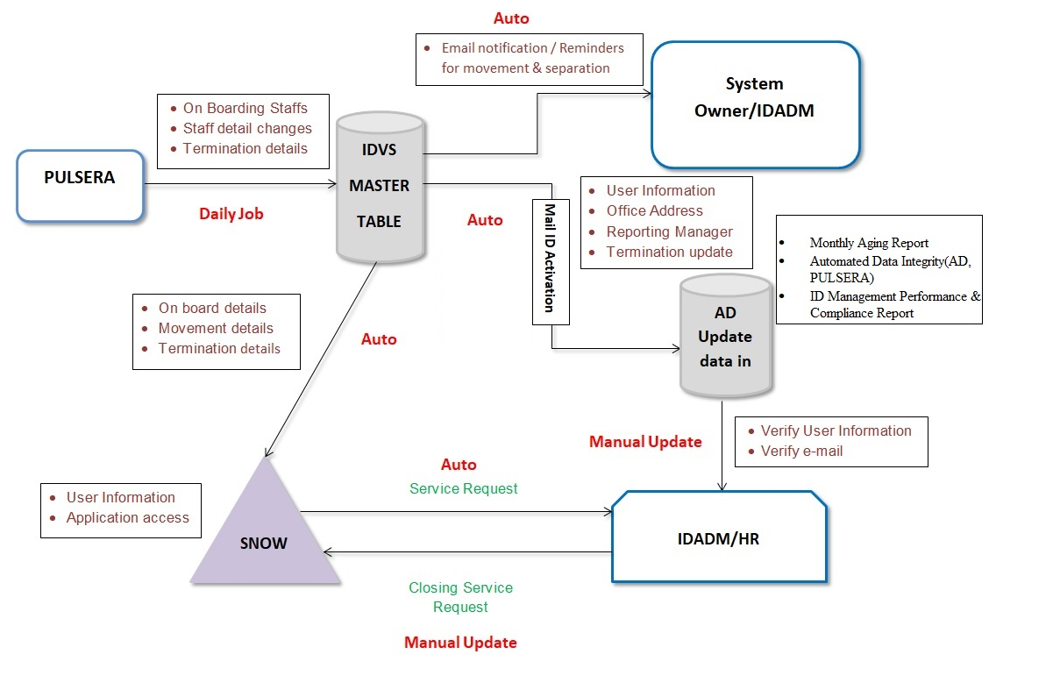

Figure 1 - IDVS Business Overview

IDVS system is used to manage all MAB application’s user separation and division movement. IDVS application will also notify the application owners with the separation and division details of its users.

**Business process:**

**New Rehire:**

**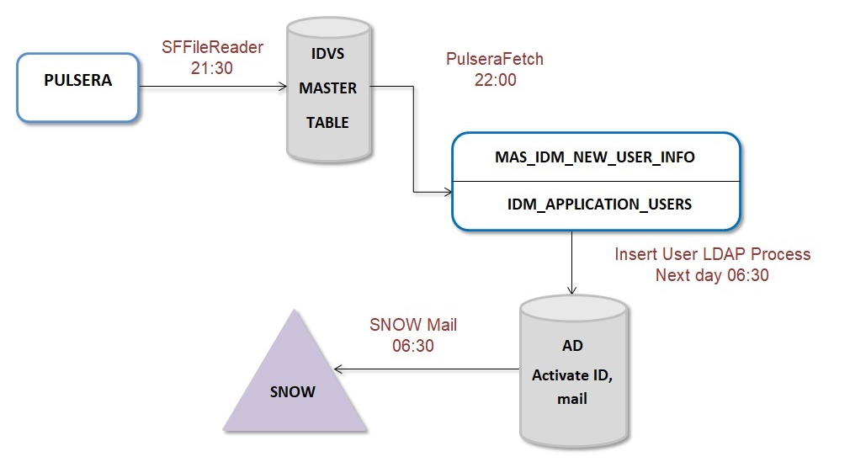**

* + - 1. Pulsera sends New & Rehire Data to IDVS.
      2. IDVS process the data and create default application named as Pulsera for the new staff id.
      3. It will activate the data into AD and VPN.
      4. It will send the data to 1Solution to raise a new joiner request.

**Separation data:**

**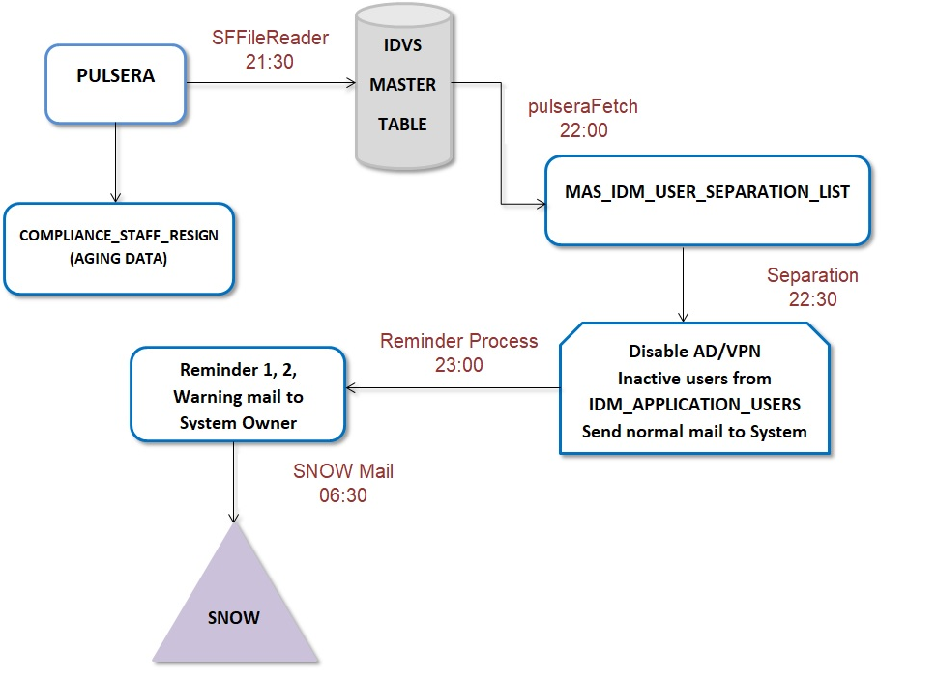**

Get the separation data from Pulsera.

It can disable the ID in AD and VPN.

Terminated staff id application user’s status will be updated as pending deactivation.

It notifies the application user to the IDADM team.

If the application user access not removed then it will go into reminder 1, reminder 2 and warning.

Still if the access is not removed after warning then it goes to compliance report.

Once the Staff id terminated the request goes to 1Solution to raise a seperation request (off boarding process).

**Movement Data:**

**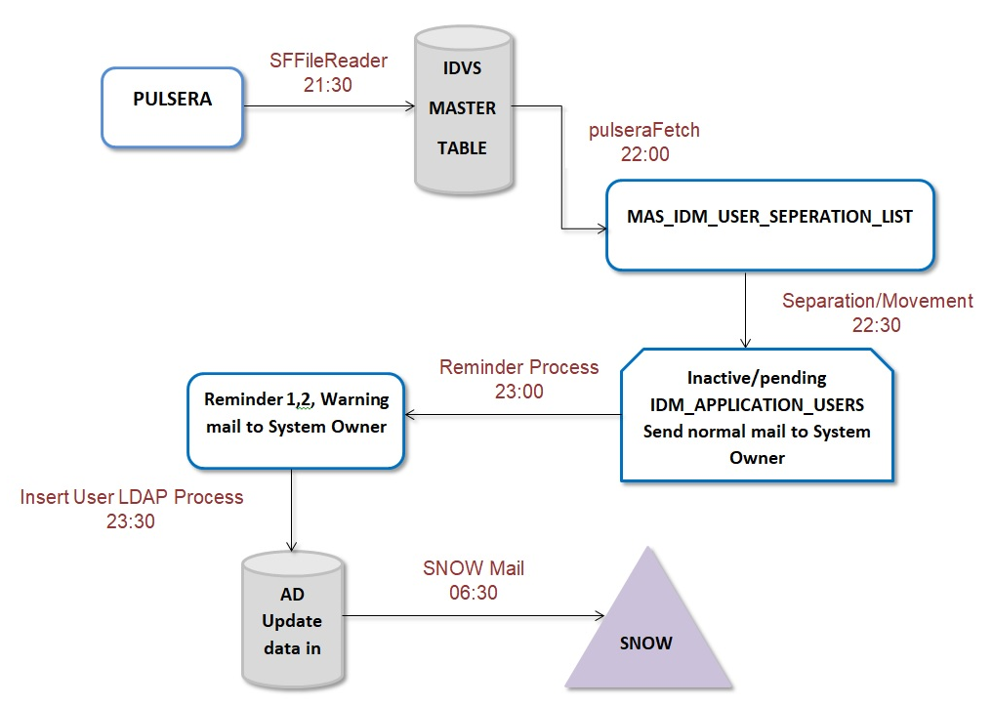**

1. Get the data from Pulsera, movement data will be updated in AD.
2. It will send it to 1Solution to raise a new movement request.

PART 4 – MANUAL CONTENT

# 4.1 Systems overview

IDVS Web application is designed and developed to be used by Administrator or Business user to manage users of IDVS System (By Administrator) and to manage Application Users (By System Owners and ID Administrator).

Based on the role assigned, the user can view the functionalities below:

If the user is a Super Admin/System Administrator, these are the functionalities that can be viewed

* Manage Application Users List
* Manage Applications
* Manage Application System Owners
* Non-Compliance System Owners
* Export/Import User List
* Reports
* Jobs Configuration
* User Management

If the user is a System Owner/ID Admin, the following are the functionalities:

* Manage Application Users
* Access Level Management
* My Activities
* Export/Import User List

**Automation Report :**

1.Automated Compliance reporting-Produce monthly aging report of staff resignation received from Pulsera:

Report generation with Staff details and count. Persist resignation data for report.

resignation info received on time, 7, 14, 30 days.

2. Automated Compliance reporting: produce ID management performance & compliance report (scheduled and adhoc)

3.Automated data integrity: Upload AD, PULSERA data. To perform data matching – compare data in IDVS vs data in Pulsera vs Active Directory.Data comparison Active in Pulsera and Active in AD. Data comparison Active in IDVS and In Active in Pulsera.

# 4.2 SYSTEM CONCEPT DIAGRAM

The overall logical System Architecture is as per diagram shown below:

BCD level for the application is BCD4.

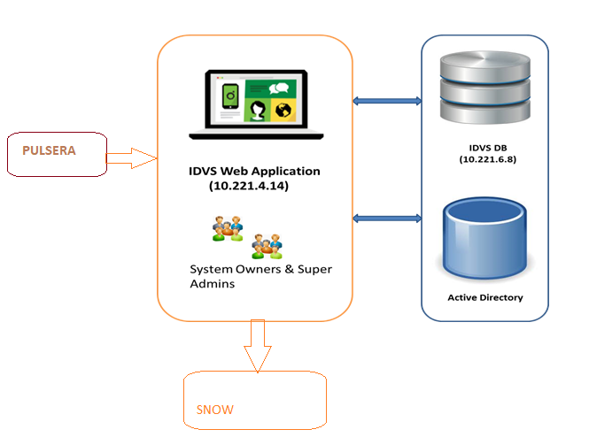

Figure 2 - IDVS Concept Diagram

# 4.3 INTERFACES

## 4.3.1 User Interfaces

The end users shall access the reports offered by IDVS, via normal Web browser available in their computer and accesses to the system shall be allowed for Intranet.

The application will be accessible through the following link via intranet.

[**http://idvs.mas.net**](http://idvs.mas.net)

**<http://3idvsapp.mas.net:8080/Id_Management>**

Browser support:

|  |  |  |
| --- | --- | --- |
| **SI.NO** | **Browser** | **Support** |
| 1 | Google Chrome | Yes |
| 2 | IE | Yes |
| 3 | Firefox | Yes |
| 4 | Safari | Yes |

Table 5 - User Interfaces

## 4.3.2 System Interfaces

Interface with MAB Corporate Active Directory

IDVS will have integration with the Active Directories (LDAP) for Security Authentication purposes. The integration with Active Directories shall adopt the existing standards currently practiced by Group IT.

User can login into application using MH domain credentials and it will be validated using LDAP Validator.

|  | **Interfaced system** | **Description** | **Transfer Mode** |
| --- | --- | --- | --- |
| 1. | LDAP | The application is interfaced with the LDAP active directory to validate and get user information. | HTTPS protocol |

Table 6 – System Interfaces

# 4.4 WARRANTY AND MAINTENANCE PERIOD

|  |  |  |
| --- | --- | --- |
| **Warranted Items** | **Start Date** | **End Date** |
| Product Warranty | Renewal from last maintenance contract | 30-Sep-2018 |
| Maintenance and Support contract | 01-May-2019 | 30-April-2020 |

Table 7 – Warranty & Maintenance Period

# 4.5 ROLES AND RESPONSIBILITIES

|  |  |  |  |  |  |
| --- | --- | --- | --- | --- | --- |
| **Role** | **Responsibility** | **Name** | **Designation** | **Company / Department** | **Contact (Phone & Email)** |
| System owner | Ensure system is operating as per designed and authorize user access to the system. | Mohd Nazri Abu Seman | Head IT | Head, Cyber Security & End User Technology  Information Technology | [+6019](tel:+60192310012" \t "_self" \o "+60192310012)2778571  & nazri.seman@malaysiaairlines.com |
| Backup Admin | Responsible to ensure backup according to schedule | Abhinav Kishore | Database Admin | TCS | +60173764522 & [ext\_abhinav.kishore@malaysiaairlines.com](mailto:ext_abhinav.kishore@malaysiaairlines.com) |
| System Admin | Responsible for installation, configuration, patching, and monitoring system performance | RajashekarReddy Kasireddy | Application Admin | ATOS | [ext\_rajashekarreddy.kasireddy@malaysiaairlines.com](mailto:ext_rajashekarreddy.kasireddy@malaysiaairlines.com) |

Table 8 – Roles and Responsibilities

MAB IT Helpdesk will provide the first level support for IDVS.

Users will call MAB IT Helpdesk for the first-level problem determination. Based on the severity and findings, the problem is to be channeled to the respective support team.

Infra and AMS Team will provide the second level support for the application infrastructure

The second level support team coverage and their role/responsibility are listed below:

| **Role** | **Responsible Party / Responsibility** |
| --- | --- |
| IDVS Administration | * Infra Mid-Range tower. * Administer the IDVS PROD and TEST servers. * Perform the operating system and application backup/recovery. * Manage server security as per security policy. * Monitoring of the systems resources and ensure servers performance and availability is per SLA. * Gatekeeper for application fixes deployment. * Troubleshooting infrastructure related problems. * Administering MySQL * Perform OS and MySQL patches maintenance and implement upgrade or patch releases. |
| IDVS Support | * AMS * 2nd level application support. * Coordinating application fixes and upgrade deployment   + perform UAT together with BU   + raise RFC for CAB * Coordinating with Infra to deploy fixes and upgrade   + Verify fixes together with BU * Reports and Monitoring the application technical problem |
| IDVS MySQL Database Administration | * Infra Database tower * Perform database maintenance and implement MySQL upgrade or patch releases. * Perform database recovery. * Manage database security as per security policy. |
| Tivoli Monitoring Administration | * IT-Ops Infra Mid-Range tower. * Ensure all components (hardware resources, daemons) of application are monitored and abnormal system behaviours are informed to operators and Application System Administrator. |
| Commvault Storage Management | * IT-Ops Infra Mid-Range tower * Monitor Linux, applications, MySQL DB are backup as per schedule backup via Commvault |
| IDVS User’s PC administration | * Desktop Support |
| WAU Group | * Responsible for monitoring the application server system health and TEC messages. * Responsible to escalate problems detected from TEC console and error log |
| MAB Helpdesk | * Single point of contact to coordinate when the problems occurred. * Responsible to coordinate problem reporting to the respective parties. |

Table 9 - Second Level Support

# 4.6 Technical specifications

## 4.6.1 Hardware specifications

| **No** | **Hardware** | **DNS Name** | **IP address** | **Location** | **Specification and Description** |
| --- | --- | --- | --- | --- | --- |
| 1. | Database Production  Server | MASG-1IDVSDB1 | 10.221.6.8 | Azure VM,Public Cloud, Singapore | Production Database Server  Resources allocated :-  Azure VM Size Standard A2\_V2(2 cores,4 GB memory)  OS Version RHEL 7.2  CPU 2  Memory (GB) 4  SWAP (GB) 8 |
| 2 | Application Production  Server | MASG-1IDVSAPP1 | 10.221.4.14 | Azure VM,Public Cloud, Singapore | Production Application Server  Resources allocated :-  Azure VM Size Standard A2\_V2(2 cores,4 GB memory)  OS Version RHEL 7.2  CPU 2  Memory (GB) 4  SWAP (GB) 8 |
| 3. | Database Test Server | MASG-3IDVSDB | 10.221.14.16 | Azure VM,Public Cloud, Singapore | Test Database Server  Resources allocated :-  Azure VM Size Standard A2\_V2(2 cores,4 GB memory)  OS Version RHEL 7.2  CPU 2  Memory (GB) 4  SWAP (GB) 8 |
| 4. | Application Test Server | MASG-3IDVSAPP | 10.221.12.13 | Azure VM,Public Cloud, Singapore | Test Application Server  Resources allocated :-  Azure VM Size Standard A2\_V2(2 cores,4 GB memory)  OS Version RHEL 7.2  CPU 2  Memory (GB) 4  SWAP (GB) 8 |

Table 10 - Hardware Specifications

## 4.6.2 Software specifications

List of software and corresponding releases used for IDVS application list below:

| **No** | **Software** | **Specification** |
| --- | --- | --- |
|  | Application & Database Server Operating System | RHEL 7.2 |
|  | Monitoring application | Tivoli 6.2 |
|  | Programming Language - UI | Java, Webservices & JSP, JavaScript |
|  | Programming Language - DB | PL/SQL |
|  | Front-end | IE 8+, Firefox 5+, Chrome 18+, Safari 5+, Opera 9+ |
|  | Application | Tomcat 8.5.9 |
|  | Webserver | Apache 2.4.23 |

Table 11 - Software Specifications

## 4.6.3 Communication / Network Specification

The IDVS application users will be accessing the application over the WAN from KLIA-ACC. The network bandwidth of 20 Kbps per user sessions with each user having 3 sessions is expected. The total network bandwidth requirement for all the users will be around 3Mbps +. It is anticipated that the existing network is able to support the required bandwidth where currently the network bandwidth from KLIA to CX2 is about 100Mbps with the utilization of 10Mbps

Below are the lists of ports used:

| **Hostname** | **Service** | **Ports used** |
| --- | --- | --- |
| 1IDVSAPP1.MAS.NET | HTTPS | 8080 |
| 1IDVSDB1.MAS.NET | MySQL | 3036 |
| 1IDVSAPP1.MAS.NET | SFTP | 22 |

Table 12 - Network Specifications

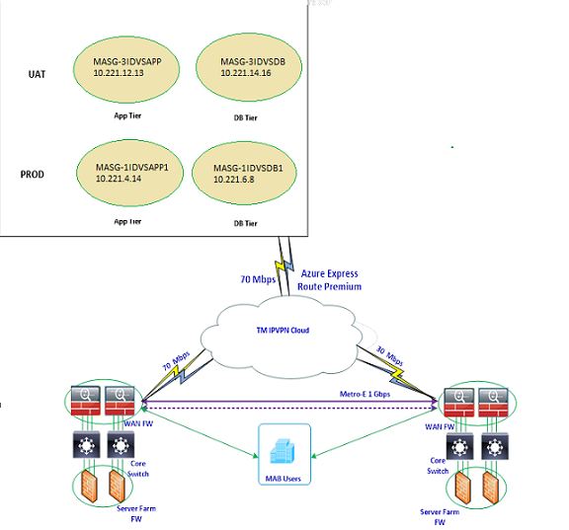

Figure 3 – Communication/Network Specification

## 4.6.4 User and Equipment Locations

User’s PCs have been upgraded or replaced to meet the IDVS requirement as below:

|  |  |
| --- | --- |
| **CPU** | Intel/AMD 2 GHz or Above |
| **RAM** | 2GB RAM memory or Above |
| **Monitor** | 800 x 600 resolution VGA color |
| **Operating System** | Windows XP or Above |
| **Disk** | 80 GB (less than 1GB is required) |
| **Software** | Internet Explorer Web browser - IE 8.0/Google Chrome/Fire fox  Acrobat Reader 9.0 to read the Report |
| **Network** | PC must be within MAB LAN/WAN network |
| **Specific Configuration** | If Proxy server is set on in the IE browser, ensure that the \*mas.net.\* is exempted. The performance may be slower if it goes through proxy. To change go to -> IE->Tools->Internet Options->Connection->LAN Setting->Advances->Exceptions. |

Table 13 – User & Equipment Locations

## 4.6.5 File Management

## 4.6.5.1 Libraries and files

#### NA

## 4.6.5.2 DBMS setup

#### Instance Names

ID\_MANAGEMENT for production database

#### Database Overall Size

Approximately 350GB disk space is required for Production instance.

# 4.7 Technical operations guide

This section describes all technical activities to be performed by IT Operations to operate and maintain the system

## 4.7.1 Installation Procedures

NA

## 4.7.2 Backup and Recovery

Recovery Services vault is an entity that stores all the backups and recovery points that have been created over time. The vault also contains the backup policies that will be applied to the virtual machines being backed up.

When the Recovery service initiates a backup job at the scheduled time, it triggers the backup extension to take a point-in-time snapshot. The Azure Recovery service uses the VMSnapshot extension in Windows, and the VMSnapshotLinux extension in Linux. The extension is installed during the first VM backup.

Once the Azure Backup service takes the snapshot, the data is transferred to the vault. To maximize efficiency, the service identifies and transfers only the blocks of data that has changed since the previous backup.

When the data transfer is complete, the snapshot is removed and a recovery point is created.

|  |  |  |  |  |
| --- | --- | --- | --- | --- |
| **Server/Database** | **# of Versions** | **Frequency** | **Schedule (MYT)** | **Remarks** |
| MASG-1IDVSAPP1 | 90 | Daily | 1.00 AM MYT | Daily incremental backup is applicable only for /home/idvsftpadmin file system |
| MASG-1IDVSDB1 | 6 | Every Saturday | 5.30 PM MYT | Monthly first Saturday backup retention is 3 months |
| MASG-3IDVSAPP | 4 | Every Saturday | 5.30 PM MYT | Monthly first Saturday backup retention is 2 months |
| MASG-3IDVSDB | 4 | Every Saturday | 5.30 PM MYT | Monthly first Saturday backup retention is 2 months |

Table 14 - Backup & Recovery

## 4.7.3 System Startup and Restart

|  |  |  |  |
| --- | --- | --- | --- |
| **Hostname** | **IP Address** | **Server Function** | **Application Startup Procedure** |
| MASG-1IDVSAPP1 | 10.221.4.18 | Production Application | Tomcat -> bin -> startup.sh |
| MASG-3IDVSAPP | 10.221.12.20 | UAT Application | Tomcat -> bin -> startup.sh |

Table 15 – System Startup & Restart

## 4.7.4 System Shutdown

|  |  |  |  |
| --- | --- | --- | --- |
| **Hostname** | **IP Address** | **Server Function** | **Application Shutdown Procedure** |
| MASG-1IDVSAPP1 | 10.221.4.18 | Production Application | Tomcat -> bin ->shutdown.sh |
| MASG-3IDVSAPP | 10.221.12.20 | UAT Application | Tomcat -> bin ->shutdown.sh |

Table 16 – System Shutdown

## 4.7.5 Monitoring Tools

The IDVS Production servers will be monitoring by IBM Tivoli Monitoring. Refer to Tivoli Monitoring document (TEC Events Escalation Procedure).

## 4.7.6 Source Code Version Control

The source code and versioning of IDVS application is being managed by the ATOS .

## 4.7.7 Preparation of Production Environment

### 4.7.7.1 Program / macro

The IDVS application has been installed in Production servers.

### 4.7.7.2 Network Definitions

The following hostnames have been defined in the DNS:

1. 1IDVSAPP1.MAS.NET– IP address 10.221.4.14

2. 3IDVSAPP.MAS.NET– IP address 10.221.12.13

3. 1IDVSDB1.MAS.NET– IP address 10.221.6.8

### 

### 4.7.7.3 Desktop Configuration

Current desktop configuration for IDVS users*:*

|  |  |
| --- | --- |
| **CPU** | Intel/AMD 2 GHz or Above |
| **RAM** | 2GB RAM memory or Above |
| **Monitor** | 800 x 600 resolution VGA color |
| **Operating System** | Windows XP or Above |
| **Disk** | 80 GB (less than 1GB is required) |
| **Software** | Internet Explorer Web browser - IE 8.0/Google Chrome/Firefox  Acrobat Reader 9.0 |
| **Network** | PC must be within MAB LAN/WAN network |
| **Specific Configuration** | If Proxy server is set on in the IE browser, ensure that the \*mas.net.\* is exempted. The performance may be slower if it goes through proxy. To change goto -> IE->Tools->Internet Options->Connection->LAN Setting->Advances->Exceptions. |

Table 17 – Desktop Configuration

## 4.7.8 Batch Jobs

Following are the list of batch jobs for IDVS:

1. SF File Reading Job at 21:30 MYT (Daily)
2. Pulsera Job at 22:00 MYT (Daily)
3. Separation Process Job at 22:30 MYT (Daily)
4. Reminder Process Trigger at 23:00 MYT (Daily)
5. Report Process Trigger at 6:00 AM MYT (Quarterly 30th of MAR,JUN,SEP,DEC)
6. ADVPN Validation Job at 7:00 AM MYT (1st of every Month)
7. ITCB AppUser Process at 10:00 AM MYT (1st of every Month)
8. NotIdvs Staff Process at 9:00 AM MYT (1st of every Month)
9. Monthly Report Process at 9:30 AM MYT (1st of every Month)
10. Insert User Ldap Process Job at 06:00 MYT (Daily)
11. SNOW Mail Job Job at 06:30 MYT (Daily)

## 4.7.9 Report Management

IDVS can produce numerous reports mostly in pdf and excel format. User can download the report and few reports are sent through Mail.

**4.8 Maintenance and support**

This section provides information to Help Desk personnel who are expected to receive problem or error reports from IDVS users.

## 4.8.1 Problem Logging

IDVS users will log problem pertaining to IDVS application to Helpdesk by telephone call or by sending memo to HELPDESK.

Helpdesk will provide 1st level support, log problems and assign accordingly.

## 4.8.2 Problem Categorization and Escalation

|  |  |  |  |  |
| --- | --- | --- | --- | --- |
| **Business Unit** | **Business Unit** | **1st Level Support** | **2nd Level Support** | **3rd Level Support - Vendor Warranty Support** |
| Business Users | Business Support Personnel | IT Helpdesk | IT Operations   * AMS | * IDVS application – third level support |
| IT Operations   * Infra | TCS   * Hardware maintenance |

Table 18 – Problem Escalation Matrix

Helpdesk will analyze the problem and assign a ticket number and a severity level which is mutually agreed by the user based on the Group IT SLA.

Apart from Helpdesk channeling the problem ticket, the DC Operators will monitor the TEC Console for any occurrence of events monitored by the Tivoli Monitoring. The list of events are documented in the Tivoli Monitoring for IDVS. Upon receiving of TEC event, the Operators notify the following IDVS support staff by telephone call for urgent and critical problem or send MEMO or both.

| **No** | **Problem Category** | **Level** | **Problem Description** | **Escalation** |
| --- | --- | --- | --- | --- |
| 1 | Hardware problem | 3 | PC hardware or configuration problem where unable to start-up the PC or the standard desktop application. | Desktop Support |
| 2 | Unable to launch the Application. | 3 | - Page error  - Invalid User ID/ Password when launching IDVS application forms | AMS Support (1st) IDVS Administrator and DBA (2nd) for Infra related. |
| 5 | PC unable to connect to LAN/WAN. | 3 | Users PC at site unable to connect to network | Network Support. |
| 6 | Unable to login to the Application | 3 | Unable to login to application due to invalid ID or password. | IDVS User Administrator |

Table 19 – Problem Category & Description

## 4.8.3 Application / Technical Support

For all infra related problems, Helpdesk will channel the problem ticket to the following support personnel:

|  |  |  |
| --- | --- | --- |
| **Name** | **Responsibility Area** | **Contact (Email)** |
| IT Helpdesk | L1 support | [helpdesk@malaysiaairlines.com](mailto:helpdesk@malaysiaairlines.com) |
| Venkata Karthihck | Midrange | [ext\_venkata.karthick@malaysiaairlines.com](mailto:ext_venkata.karthick@malaysiaairlines.com)  GD\_TCSMidrange <GD\_TCSMidrange@malaysiaairlines.com> |
| Abdul | Wintel | [ext\_abdulkhader.mohamedabusali@malaysiaairlines.com](mailto:ext_abdulkhader.mohamedabusali@malaysiaairlines.com)  GD\_TCSWintel <GD\_TCSWintel@malaysiaairlines.com> |
| Abhinav Kishore | Database | [ext\_abhinav.kishore@malaysiaairlines.com](mailto:ext_abhinav.kishore@malaysiaairlines.com)  GD\_TCSDatabase <GD\_TCSDatabase@malaysiaairlines.com> |
| Ravisankar | Network Support | [ext\_ravisankar.balasubramanian@malaysiaairlines.com](mailto:ext_ravisankar.balasubramanian@malaysiaairlines.com)  GD\_TCSNetwork <GD\_TCSNetwork@malaysiaairlines.com> |
| RajashekarReddy Kasireddy | Application Support, Onsite-Primary | [ext\_rajashekarreddy.kasireddy@malaysiaairlines.com](mailto:ext_rajashekarreddy.kasireddy@malaysiaairlines.com) |
| Group ID | IDVS support team | [GD\_AMS\_SRAS@malaysiaairlines.com](mailto:GD_AMS_SRAS@malaysiaairlines.com) |

Table 20 – Technical Support Details

# User guide

|  |  |  |
| --- | --- | --- |
| **No** | **User guide** | **Location of document** |
| 1 | IDVS User Guide for System Owner and Super Admin | https://mabitdept.sharepoint.com/sites/MyPulse/InformationTechnology/ServiceDeliveryManagement/System%20Operating%20Document%20SOD/Forms/AllItems.aspx |

Table 21 – User Guide

## 4.9.1 Accessing the Application

IDVS application is deployed in web based environment, the client workstation uses the web browser to connect to the web server through LAN/WAN. The web server runs the application and communicates with the database server for exchanging the data.

Access IDVS via URL: [**http://idvs.mas.net**](http://idvs.mas.net)

**4.10 CONTRACTmanagement**

|  |  |  |
| --- | --- | --- |
|  | **Contract** | **Parties** |
| 1. | Service contract for AMS support services | Signed between MAB and ATOS |

Table 22 – Contract Management

# 4.11 Handover items

The following documents / items will be handed over to Operations together with this System Operation Document during the Handover session.

* Technical Design Document
* System Operation Document
* User signoff by Business Users

**4.12 Information security**

**4.12.1 AUDIT AND COMPLIANCE REQUIREMENTS**

|  |  |  |
| --- | --- | --- |
| **Activity** | **Frequency** | **Responsible Party** |
| Perform ID review every quarter and submit result to Technology and Cyber Risk Governance  [Req: ISO 27001, PCI-DSS] | Quarterly | ID Admin |
| Update user access matrix and submit to Technology and Cyber Risk Governance  [Req: ISO 27001, PCI-DSS] | Yearly | System Owner |
| Install Critical Security Patches for the application and submit report to Technology and Cyber Risk Governance  [Req: ISO 27001, PCI-DSS] | Quarterly | System Owner |
| Performed Backup restoration  [Req: ISO 27001, PCI-DSS] | Yearly | System Owner |
| Review & update security documentation and submit to Technology and Cyber Risk Governance:   * Super/privilege IDs and access * Security Controls Setting * Audit Logs setting * System bypass * List of connections and integration * List of used ports * Data encryption setting * Application/system schematic diagram   [Req: ISO 27001] | Yearly | System Owner |

Table 23 – Audit & Compliance Requirements

**4.12.2 PASSWORD POLICY COMPLIANCE**

|  | **Password Policy Requirements** | **Yes** | **No** | **Remarks** |
| --- | --- | --- | --- | --- |
|  | Password length at least 8 characters (minimum) | Yes |  |  |
|  | Alphanumeric | Yes |  |  |
|  | Change temporary password at first logon | Yes |  |  |
|  | Password expiry = 90 days (maximum) | Yes |  |  |
|  | Password reuse generation = 5 (minimum) |  | No |  |
|  | Account lock out after 5 failed login attempts | Yes |  |  |
|  | Application shall disconnect or suspend inactive sessions= 15 Minutes | Yes |  |  |
|  | Wrong password shall be recorded in an audit log |  | No |  |

Table 24 – Password Policy Compliance

**4.12.3 USER ACCESS MATRIX**

|  |  |  |  |  |
| --- | --- | --- | --- | --- |
| **USER TYPE** | **ACCESS LEVEL** | | | |
| **User Management** | **Report Generation** | **NA** | NA |
| Administrator | Yes | Yes | NA | NA |
| Normal | No | Yes | NA | NA |

Table 25 – User Access Matrix

# 4.13 Documentation and references

|  |  |  |
| --- | --- | --- |
|  | ***Document*** | ***Location of source*** |
| *1.* | *System Operation Document IDVS* | *https://mabitdept.sharepoint.com/sites/MyPulse/InformationTechnology/ServiceDeliveryManagement/System%20Operating%20Document%20SOD/Forms/AllItems.aspx* |
| *2.* | *User Guide for IDVS* | *https://mabitdept.sharepoint.com/sites/MyPulse/InformationTechnology/ServiceDeliveryManagement/System%20Operating%20Document%20SOD/Forms/AllItems.aspx* |

Table 26 – Documents & References

**INTENTIONALLY LEFT BLANK**

# AppendiX

**RELEASE MANAGEMENT REPORT**

|  |  |  |  |  |
| --- | --- | --- | --- | --- |
| **S.No.** | **Change Request** | **Implementation Date** | **Change Description** | **Document Version** |
| 1 | NCR000004429 | 30-05-2016 | Initial Release | 1.0 |
| 2 | CHG0011486 | 17-11-2017 | To avoid duplicate records loading into DB | 1.0 |
| 3 | CHG0018711 | 30-07-2020 | MYSQL Migration from mysql-connector-java-5.1.26 to mysql-connector-java-8.0.20.  Upgrade MYSQL drivers & SQL modifications in the application code. | 1.1 |
| 4 | CHG0018826 | 16-08-2020 | Pulsera division data loading | 1.1 |
|  | CHG0018071 | 16-08-2020 | Implementation for  Automated Compliance reporting  To produce ID management performance & compliance report (scheduled and adhoc)  To produce monthly aging report of staff resignation received from Pulsera | 1.1 |

Table 27 – Release Management

**PATCH MANAGEMENT REPORT**

Application : \_\_\_\_\_\_\_\_\_\_\_\_\_\_\_\_\_\_\_\_\_\_\_Nil\_\_\_\_\_\_\_\_\_\_\_\_\_\_\_\_\_\_\_\_\_\_\_\_\_\_\_\_\_\_\_

Owner **: \_\_\_\_\_\_\_\_\_\_\_\_\_\_\_\_\_\_\_\_\_\_\_NIL\_\_\_\_\_\_\_\_\_\_\_\_\_\_\_\_\_\_\_\_\_\_\_\_\_\_\_\_\_\_**

|  |  |
| --- | --- |
| **Date** | **Patch / Service Pack Applied** |
| **NIL** | **NIL** |
|  |  |
|  |  |
|  |  |

Table 28 – Patch Management Report

**Prepared By: Approved By:**

**.................................................... ....................................................**

**System Admin System Owner**

**BACKUP RESTORATION REPORT**

Application : \_\_\_\_\_\_\_\_\_\_\_\_\_\_Nil\_\_\_\_\_\_\_\_\_\_\_\_\_\_\_\_\_\_\_\_\_\_\_\_\_\_\_\_\_\_\_\_\_\_\_\_\_\_\_\_

Owner **: \_\_\_\_\_\_\_\_\_\_\_\_\_\_\_Nil\_\_\_\_\_\_\_\_\_\_\_\_\_\_\_\_\_\_\_\_\_\_\_\_\_\_\_\_\_\_\_\_\_\_\_\_\_\_\_**

|  |  |
| --- | --- |
| **Date** | **Status of Restoration** |
| **Nil** | **Nil** |
|  |  |
|  |  |
|  |  |

Table 29 – Backup Restoration

**Prepared By: Approved By:**

**.................................................... ....................................................**

**Backup Admin System Owner**

**NON COMPLIANCE REPORT**

Application : \_\_\_\_\_\_\_\_\_\_Nil\_\_\_\_\_\_\_\_\_\_\_\_\_\_\_\_\_\_\_\_\_\_\_\_\_\_\_\_\_\_\_\_\_\_\_\_\_\_\_\_\_\_\_\_

Owner **: \_\_\_\_\_\_\_\_\_\_\_\_\_\_\_Nil\_\_\_\_\_\_\_\_\_\_\_\_\_\_\_\_\_\_\_\_\_\_\_\_\_\_\_\_\_\_\_\_\_\_\_\_\_\_\_**

|  |  |  |
| --- | --- | --- |
| **Date** | **Reference Number** | **Description** |
| **Nil** | **Nil** | **Nil** |
|  |  |  |
|  |  |  |
|  |  |  |

Table 30 – Non Compliance Report

**Prepared By: Approved By:**

**.................................................... ....................................................**

**System Admin System Owner**

**END OF DOCUMENT**